Joining Zoom Meetings for Students
Install Zoom Application:
Download URL’s
Desktop/Laptop Devices:
https://zoom.us/download
Apple Devices:
https://itunes.apple.com/us/app/id546505307
Android Devices:
https://play.google.com/store/apps/details?id=us.zoom.videomeetings
Sign Up:
- Sign up via Zoom app. Make sure to input your ICP student ID in the surname.
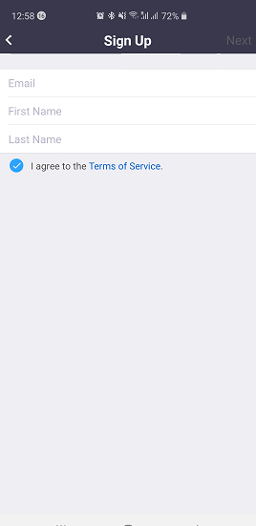
- Activate your account. 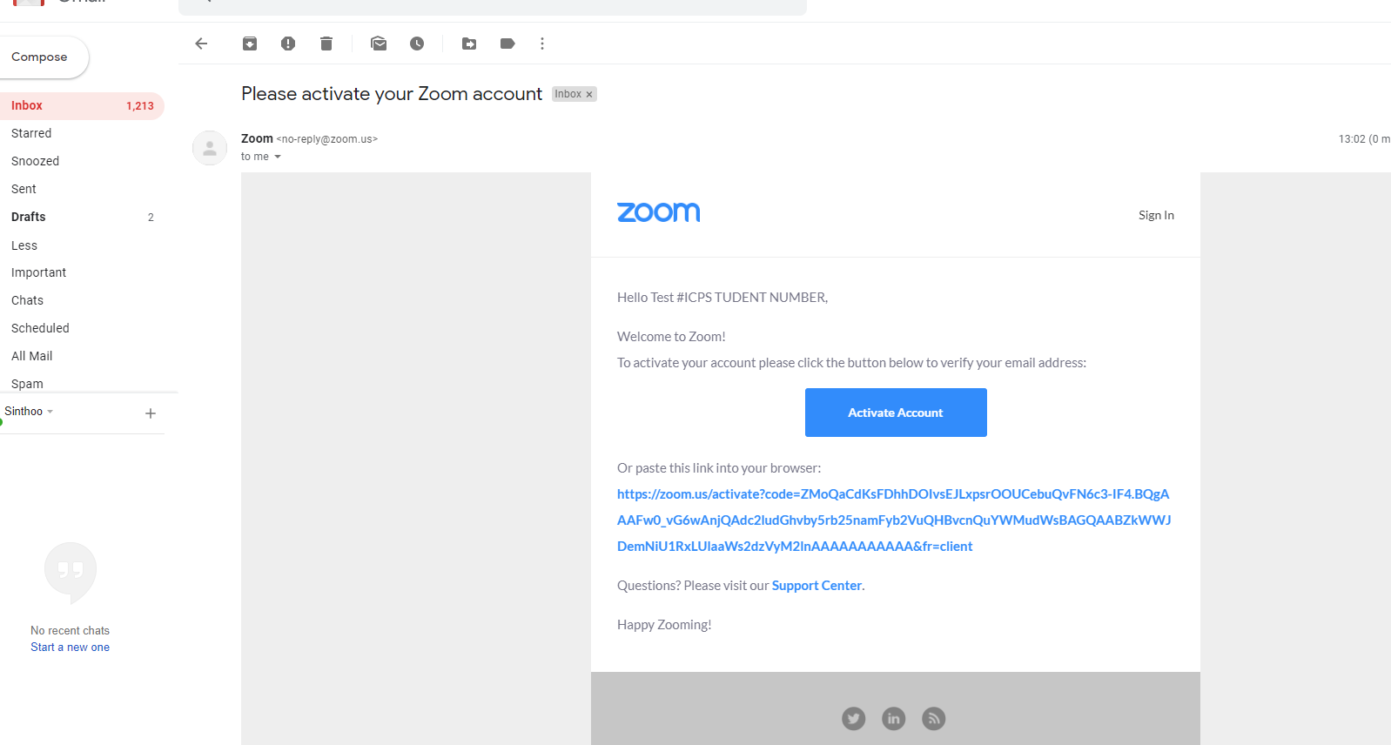

- Confirm password.

- Join Zoom Web lecture using 9-digit code supplied on your Timetable. Example below:
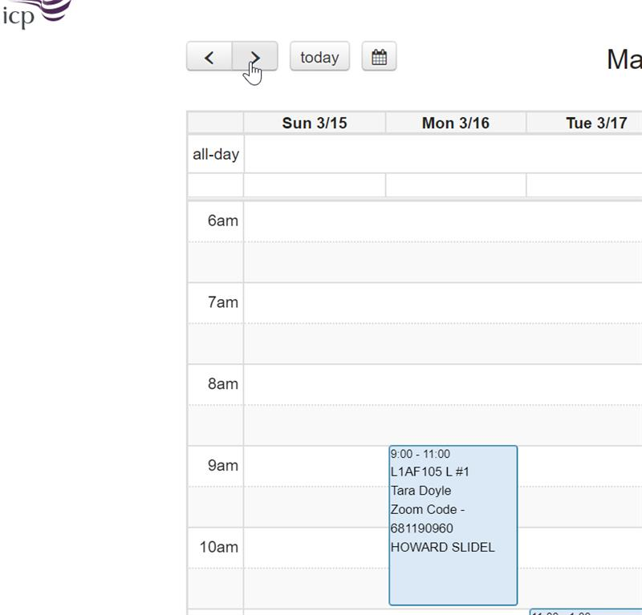
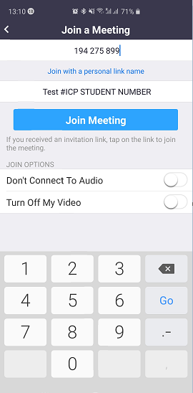

There are several ways to join a Zoom meeting:
- With the Zoom app on your personal device
- Through a link via your email invitation
From the Zoom app (join via PC, Mac, iOS or Android):
- Open the Zoom app on your device
- Click on Sign in
- Click on Join
- Enter the Meeting ID (this is displayed on your Timetable)
- Enter your ICP Student ID/Name as your display name. This is a requirement for registration to be completed.
- You can then choose whether to come into the meeting with your audio or video enabled or disabled

